1. open app.py

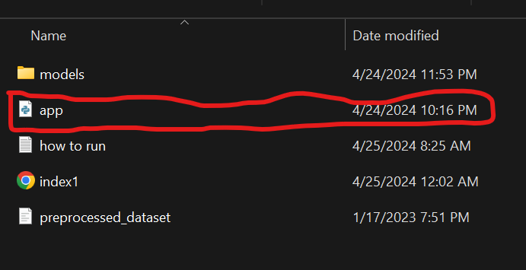

2. go to files / open folder

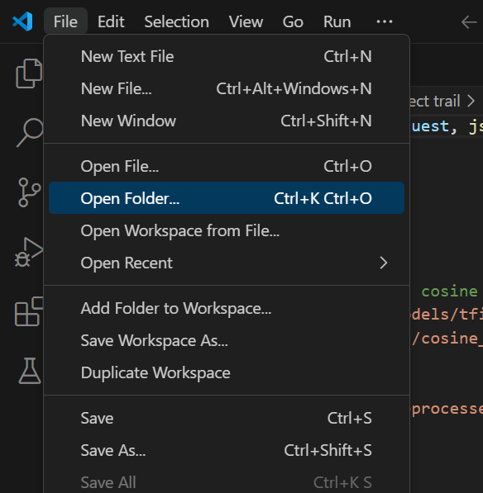

3. click select folder

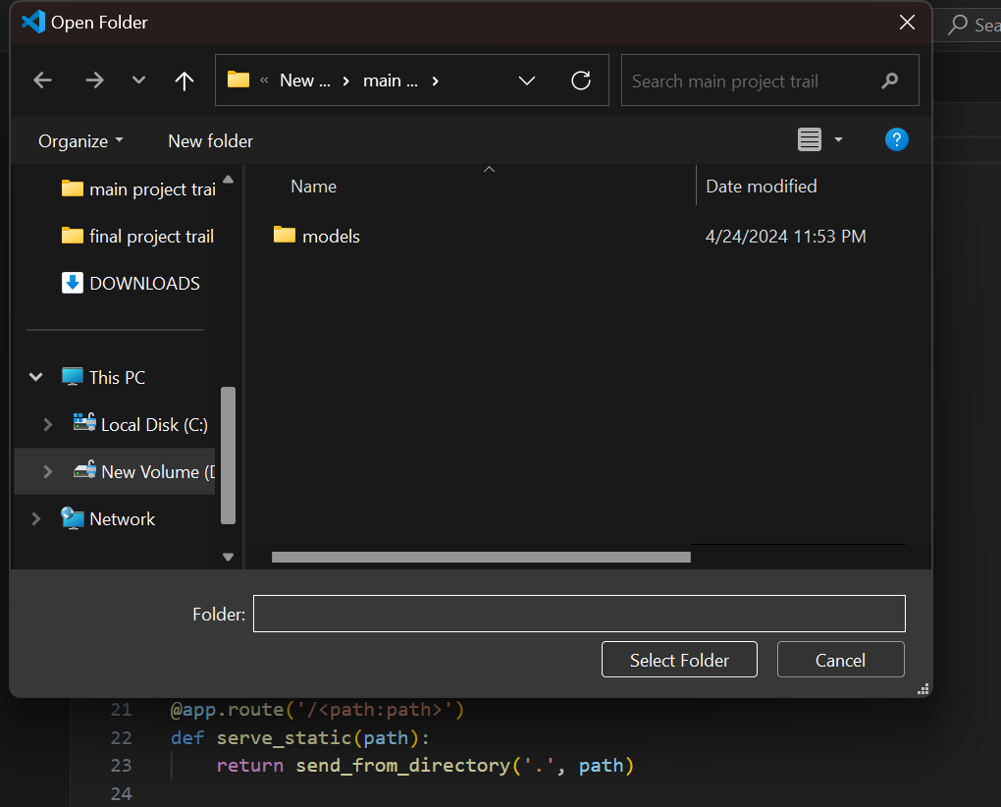

4. then run app.py by clicking the triangle on top right corner

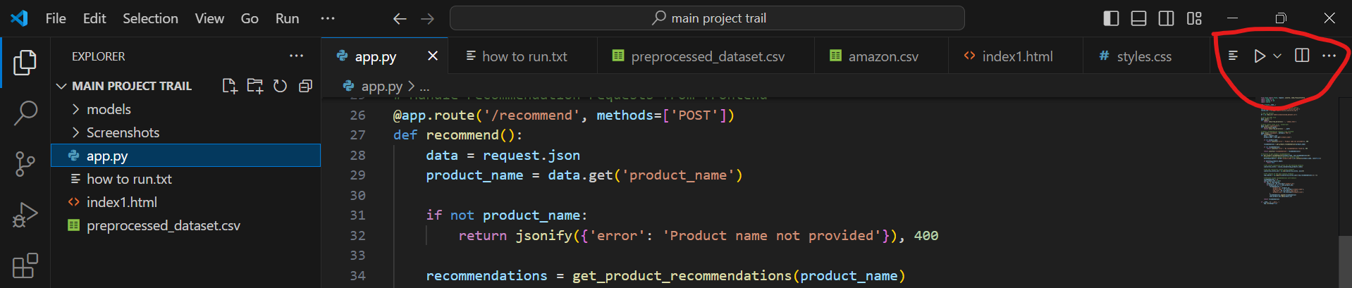

5. then on the output click the Running on http://127.0.0.1:5000

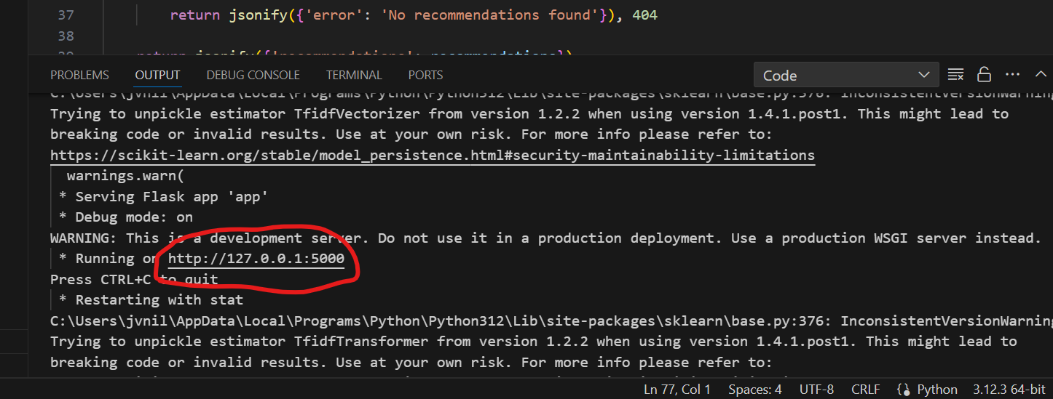

(CTRL + C to stop the project after clicking the out)

6. then the front end is running in the web browser